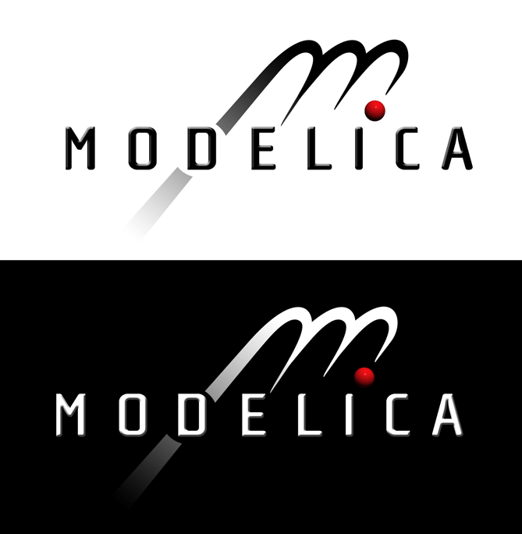

Modelica Standard Library

Version 3.0

February 2008

Tutorial and Reference

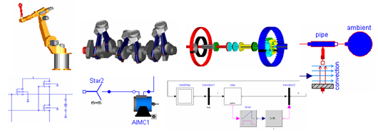

Modelica Association
http://www.Modelica.org
Copyright © 1998-2008, Modelica Association (http://www.Modelica.org)

Modelica® is a registered trademark of the Modelica Association.

This manual can be freely distributed according to the Modelica License (which holds for the source code of the Modelica Standard Library, including its documentation):

Redistribution and use in source and binary forms, with or without modification are permitted, provided that the following conditions are met:

- The author and copyright notices in the source files, these license conditions and the disclaimer below are (a) retained and (b) reproduced in the documentation provided with the distribution.
- Modifications of the original source files are allowed, provided that a prominent notice is inserted in each changed file and the accompanying documentation, stating how and when the file was modified, and provided that the conditions under (1) are met.
- It is not allowed to charge a fee for the original version or a modified version of the software, besides a reasonable fee for distribution and support. Distribution in aggregate with other (possibly commercial) programs as part of a larger (possibly commercial) software distribution is permitted, provided that it is not advertised as a product of your own.

Disclaimer:

The software (sources, binaries, etc.) in their original or in a modified form are provided "as is" and the copyright holders assume no responsibility for its contents what so ever. Any express or implied warranties, including, but not limited to, the implied warranties of merchantability and fitness for a particular purpose are disclaimed. In no event shall the copyright holders, or any party who modify and/or redistribute the package, be liable for any direct, indirect, incidental, special, exemplary, or consequential damages, arising in any way out of the use of this software, even if advised of the possibility of such damage.

Modelica is a freely available, object-oriented language for modeling of large, complex, and heterogeneous physical systems. It is suited for multi-domain modeling, for example, mechatronic models in robotics, automotive and aerospace applications involving mechanical, electrical, hydraulic and control subsystems, process oriented applications and generation and distribution of electric power. Models in Modelica are mathematically described by differential, algebraic and discrete equations. No particular variable needs to be solved for manually. A Modelica tool will have enough information to decide that automatically. Modelica is designed such that available, specialized algorithms can be utilized to enable efficient handling of large models having more than one hundred thousand equations. Modelica is suited and used for hardware-in-the-loop simulations and for embedded control systems.
Modelica is developed by the Modelica Association, a non-profit organization with seat in Linköping, Sweden. The Modelica Association also develops the free Modelica Standard Library containing model components in many domains that are based on standardized interface definitions. This Manual was automatically produced from the documentation included in the Modelica Standard Library.
The source code of the Modelica Standard Library, as well as this manual, is available at http://www.modelica.org/libraries/Modelica
Links to other free and commercial Modelica libraries (utilizing the Modelica Standard Library) are available at http://www.Modelica.org/libraries.
Links and short descriptions of Modelica modeling and simulation environments are available at http://www.Modelica.org/tools.

Contents

Index 5

Include File here with “insert file”

Index
Fehler! Keine Indexeinträge gefunden.

